We are extremely excited for the 2016 Softball season to begin! Please read through the information below and contact us if you have any questions or concerns. Please make sure to fill out the parent information form at the end of the packet so that we can keep you updated and informed. Thanks!
Coach Brandi Zivilik Coach Stephanie Esteban
bzivilik@d56.org/847-336-2108 ext.1104 sesteban@d56.org/847-336-2108 ext.1401
Viking Softball Website: www.vikingsoftball.weebly.com
VIKING SOFTBALL

Eligibility: Being a part of an athletic team is a privilege offered to any student who is capable of meeting the physical, academic, and behavioral requirements. Parents and athletes should review the extracurricular code of conduct sheet together (located at the end of this packet). Athletes should be aware that their conduct is being evaluated by the school district’s administrators, teachers, coaches, chaperones, and bus drivers. After the 3rd time an athlete is ineligible due to academic or behavioral reasons, she will be removed from the team.

Practices: Practice days and end times are noted on the attached calendar. Athletes should be picked up at the Viking Softball field on practice days. After three instances where an athlete is still waiting for a ride 15 minutes late, you may be asked to forfeit your place on the team. If you miss a practice, it will only be excused due to illness, another school activity, or with a doctor’s note. For 1st and 2nd unexcused absences, the athlete will sit out the next game. After 3, the athlete will be removed from the team. In the event of rain, students should listen for announcements to find out about practice that day. Please let your coach know in person or by email if you will not be at practice, even if you are absent from school that day.

Games: Athletes will stay after school and be bused to all games. Games usually begin between 3:30 and 3:45, but time can vary depending on the dismissal times of the participating schools and when the teams all arrive. You will be bused back to Viking from all games. You may sign out and leave with a parent at the site of the game or be picked up at Viking after the game. Signing out means you need to tell one of the two coaches that you are leaving. In order to go home with another parent, you must have written permission from your own parent. If you know there is a game that you cannot attend because of another commitment, please let your coach know in person or by email, even if you are absent from school that day. The decision to cancel a game because of the weather will often not be made until 1:00 PM.

Uniforms: All participants must wear a school-issued jersey, pants, socks, and visor (all items are provided). The visor and socks are yours to keep. Please read the washing instructions carefully for the jerseys. Students will have the opportunity to purchase a Viking Softball t-shirt and/or sweatshirt. You will be charged for the replacement of any part of YOUR uniform that is not returned at the end of the season. Return your uniform to your coach as soon as your season is over. Return it BEFORE Awards Night and receive candy!

Shoes: Softball cleats without metal spikes are necessary for practices and games. Please do not wear basketball, wrestling, or other shoes that are not suitable for softball.

Awards Night: All athletes who participated this season should join us for Awards Night at Viking School in October. The date is still yet to be determined. You will receive a certificate of accomplishment, team photos if you ordered them, and of course, cake.

Picture Day: Athletes will be given a picture form at practice. The date for Picture Day is still to be determined. If you wish to order pictures, you should bring the form on picture day and hand it to the photographer. Do not return your picture form to your coach.

PRACTICE /GAME SCHEDULE

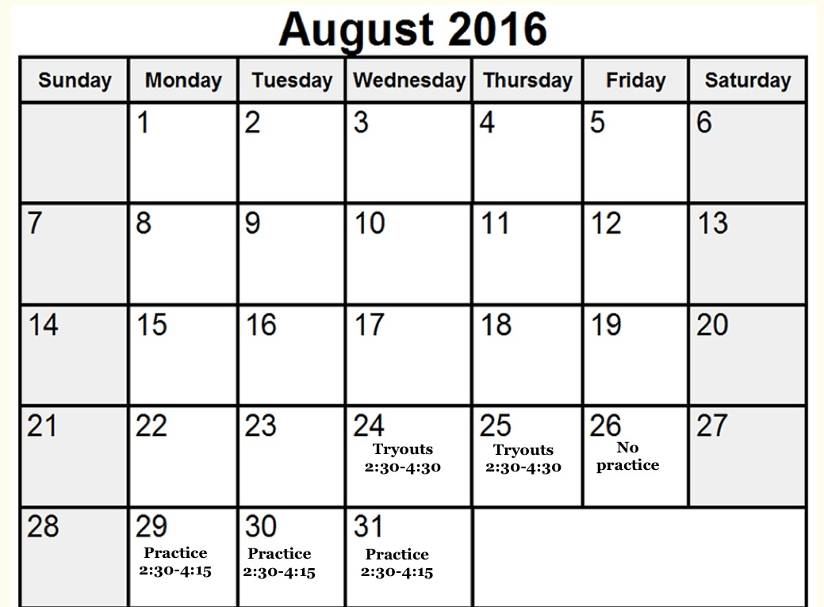

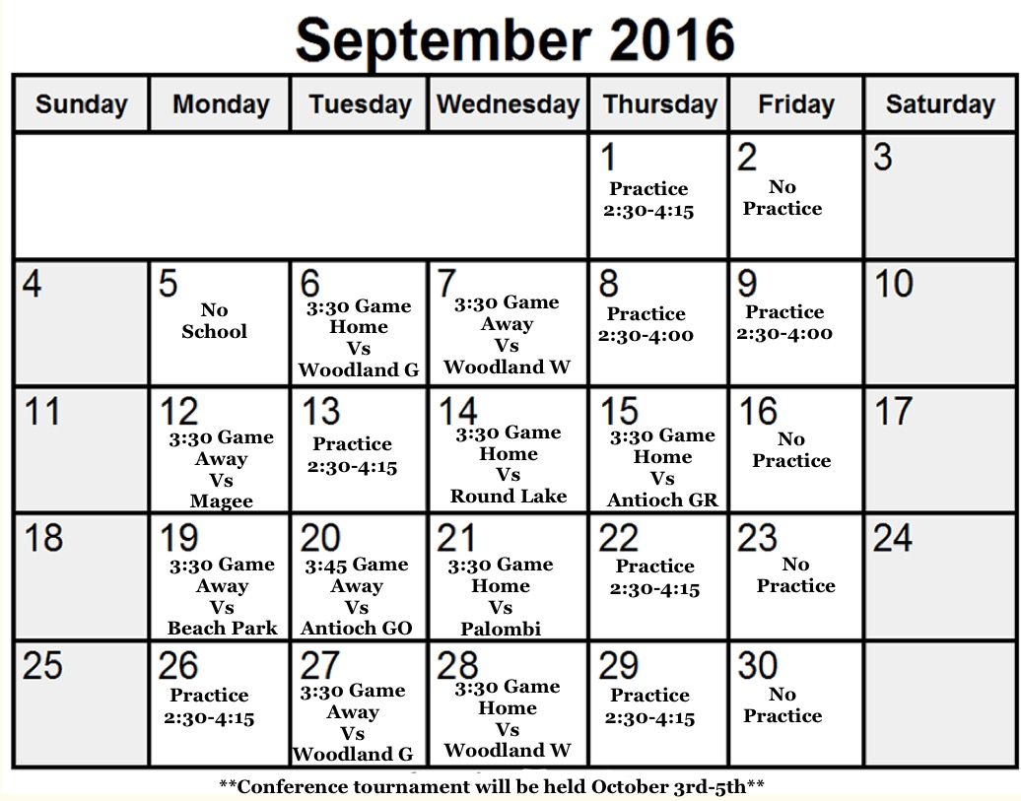

**September 30th-The 8th and 9th place team will play a play-in game for the tournament**

2016 GURNEE DISTRICT 56 SOFTBALL SCHEDULE

Tues | 9/6 | WOODLAND GREEN | HOME | 3:30
Wed | 9/7 | @ Woodland White | Away | 3:30
Mon | 9/12 | @ Magee | Away | 3:30
Wed | 9/14 | ROUND LAKE | HOME | 3:30
Thurs | 9/15 | ANTIOCH GREEN | HOME | 3:30
Mon | 9/19 | @ Beach Park | Away | 3:30
Tues | 9/20 | @ Antioch Gold | Away | 3:45
Wed | 9/21 | PALOMBI | HOME | 3:30
Tues | 9/27 | @ Woodland Green | Away | 3:30
Wed | 9/28 | WOODLAND WHITE | HOME | 3:30
Mon  Tues- | 10/3  10/4- | Conference Tourn.@ Woodland  Conference Tourn.@ Antioch HS | Away  Away
Wed | 10/5 | Conference Tourn.@ Antioch HS | Away

DIRECTIONS FOR 2016 SOFTBALL
ANTIOCH 800 HIGHVIEW DRIVE 838-8400
Take Rt. 132 west to Rt. 45. Turn right on Rt. 45 to Rt. 173. Go left on Rt. 173 past Rt. 59 to Tiffany Rd. Turn right on Tiffany and go 2 blocks to Highview Rd. Turn left on Highview Rd. to school.
BEACH PARK 40667 Green Bay Road 599-5052
Take Old Grand East to Delany. Turn Lt on Delany. Follow Delany North until Wadsworth Rd. Turn Rt. on Wadsworth. Turn Lt on Green Bay Road. Turn Rt. into parking lot past school.
LAKE VILLA 133 S. McKinley 356-2118
Go west on Grand Ave (132) to Lake Villa. Go past Rt. 83 and cross over the railroad tracks. Go one more block to McKinley Ave. and turn left. Go 3 blocks to school.
MAGEE (ROUND LAKE)
Take O’Plaine to Washington. Turn Rt on Washington. Follow West to Cedar Lake Road. Turn Lt. School is on top of hill to the right.

ROUND LAKE 2000 LOTUS DRIVE 270-9400
Take Rt. 132 west to Rt. 45. Turn Lt. on Rt. 45. Turn Rt. On to Rollins Rd. Follow Rollins Rd. west to Lotus Drive. Turn Rt. On Lotus. Follow to the school. Turn Lt. into parking lot past Middle School.

WOODLAND 7000 WASHINGTONSTREET 362-3514
Take Rt. 132 west to Almond Road. Turn left on Almond Road, the school is on the left just before Washington Street. OR Take Washington Street to Almond Road. The school is on the northeast comer of Washington and Almond.

DISTRICT 56 EXTRA-CURRICULAR CODE OF CONDUCT

In order to establish the ideals of good citizenship and respect for rules and authority; in order to establish leadership, group or team pride, facilitate cooperation, teamwork, and group responsibility; and in order to provide conditions which promote health, safety, a well balanced individual, pride in one's accomplishments, and good sportsmanship in the case of athletics, the following guidelines have been established for all students who take part in extracurricular programs at District 56.

PARTICIPATION REQUIREMENTS
Each student must comply with the following requirements before he/she is allowed to participate in the program of any activity here at District 56.
1. Each student shall obtain written permission for each sport he/she wishes to participate in, and in the case of athletics, all students must obtain a medical examination each year, which shall be on file with the school nurse.
2. Each participant must maintain a “C" average and have no failing grades. Every week the academic teams along with specials will report the names of any student whose grades have fallen below a “C". If a student becomes ineligible to participate in the program, he/she will be put on probation as determined by lESA governing policies, assistant principal, or dean. The student may not attend tryouts, practice or game contests for the duration of one week. Any student that does not become academically eligible after one week will be place on probation again. If a student becomes ineligible a third time during a season, he/she will be removed from the team. A letter will be sent home to the parents of any student who becomes academically ineligible.
3. It is expected that any student who represents District 56 as a member of an extracurricular activity will exemplify the highest standards of citizenship. Any behavior that violates this principle is unacceptable and may result in suspension from the activity. Students will not be allowed to misbehave during school hours and then participate as a member of an extracurricular activity. A letter will be sent home to the parents of any student who is suspended from an activity due to improper citizenship.
4. Parents are responsible for providing and/or arranging transportation to and from events and practices. Students who are late in arriving to an event when not taking the furnished district transportation or in being picked up promptly at the conclusion of events are subject to removal from the activity. Coaches and sponsors are required to supervise students until the student is picked up. Students who are not picked up within 5 (five) minutes of the designated time are subject to:
1) First time Verbal warning by coach/sponsor to student and parent
2) Second time Written warning to student and parent
3) Third Time Removal from the activity
5. It is expected that if a student joins an activity he/she will attend all of the required meetings. Any approved absence must be brought to the attention of the activity/sponsor in advance. A parent or guardian should notify and discuss with the coach any planed absences from an activity and the possible consequences. Un-excused absences may result in suspension from the activity and/or loss of playing time in the next contest. Students with unexcused absences are subject to:
1) First/Second time Verbal warning by coach/sponsor and possible loss of playing time
2) Third time Removal from an activity

Thank you for taking the time and reading through this. I hope the information helped. Please sign and date the sheet below, so we know that your received the information. We would also appreciate it if you could write down your contact information, so we have the best way of getting a hold of you.

Parent(s) name(s):_____________________________________________

Cell #:______________________________________________________

Email:_______________________________________________________

Other Important Info__________________________________________

Parent/Guardian Signature:____________________Date:______________

----------------------------------------------------------------------------------------------------------------------

Viking Softball T-Shirt & Sweatshirt Order Form

Name ___________________________________
T-Shirt Size Adult S M L XL XXL
Sweatshirt Size Adult S M L XL XXL
Please turn this form back in to Mrs. Zivilik or Mrs. Esteban
T-Shirts $10 Sweatshirts $20

(Checks should be made payable to District 56 – if you write
a check please make sure your phone number is on it.)

